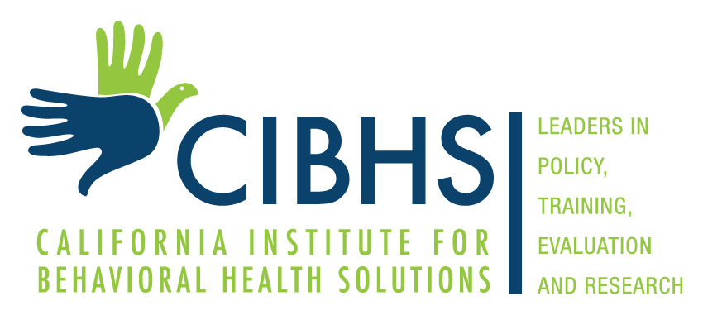

California Institute for Behavioral Health Solutions presents:

Rural Supportive Housing Training Workshops

Date and Time
February 26-27, 2018
or
March 1-2, 2018

Location
- February 26-27, 2018: Mammoth Mountain Inn, 10400 Minaret Road, Mammoth Lakes, CA 93546
- March 1-2, 2018: Sequoia Room, CIBHS, 2125 19th Street, Second Floor, Sacramento, CA 95818

Who Should Participate
Behavioral health, rural development, affordable housing and homeless services providers and advocates.

Registration
February: Please click on the link to register for Feb.
March: Please click on the link to register for March.

Cost
$75.00.
“No Place Like Home (NPLH) Technical Assistance funds may be used for this purpose.”

Training Description
Behavioral health, affordable housing and homeless services agencies have a common goal to improve the wellbeing of their clients, but they often work in silos, with different languages, acronyms, cultures, operating practices and resources. Through the Rural Supportive Housing Initiative, and partnering with Collaborative Solutions, Inc., CIBHS is pleased to provide two 2-day Rural Supportive Housing workshops designed to address housing and case management strategies that can help vulnerable clients find and keep safe, stable, and affordable homes in small counties and rural areas. These workshops will also provide a forum for networking and partnership development between local behavioral health, housing and homeless services professionals and advocates.

Workshop Topics:
Coordinated Entry: Best Practices to Plan and Implement a Rural Coordinated Entry System

The federal government has set January 2018 as the date to have a coordinated entry system (CES) in place. Many rural communities have been struggling with how to plan and implement a CES across a wide geographic area with few service providers. This workshop will guide communities through the design and planning for a CES, and offer recommendations on best practices from other rural communities. Through this workshop communities will produce a CES checklist of next steps.

Housing-based Case Management: Prioritizing Affordable Housing Provision for Clients

Many service providers have been trained to provide clinical, medically-focused supportive services for clients. It is our belief that housing is the foundation for stability and providers must be trained to understand and prioritize the affordable housing needs of clients to better help them achieve housing stability. This workshop provides essential tools and training to teach providers how to prioritize housing and includes key concepts such as low barrier program design, landlord engagement, and eviction prevention.

For more information
If you have questions regarding program information, please contact Shoshana Zatz at szatz@cibhs.org. If you have questions regarding hotel reservations or registration, please contact Gerilyn Walcott at gwalcott@cibhs.org

