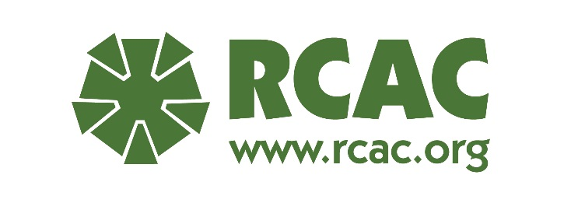
Class Fees and Scholarship Policy
Classes are available to those employed by a HUD-approved counseling agency. At registration, participants will be required to identify their HUD number. If a counseling agency is still in the HUD approval process, RCAC will need to secure approval from HUD for the participant to be allowed entry into the class.
Fees
Class fees are $50 per day for in-person classes and $25 for each webinar series. Refunds will be honored up to one week before the class begins. Refund amount will equal the amount paid minus a $25 admin fee. There will be no refunds for webinars registration.
Scholarships
These factors will be weighted in the scholarship process. At registration, participants will be asked:
- If they work in rural area or
- if newly HUD approved in the last 12 months
Scholarships will be offered on a first-come, first served basis. New agencies will be considered for scholarships before agencies that have received prior scholarships.
RCAC will consider multiple scholarship applications from the same agency with the additional requests dropping to the bottom of the scholarship request list. If no new agencies/counselors apply for scholarships and an agency has previously received a scholarship for one of its counselors, RCAC will give priority to awarding a scholarship to a new recipient in that agency before providing a second scholarship to the same counselor.
If a participant’s travel exceeds 50 miles that participant would be eligible for a travel and lodging scholarship. Travel is for airfare only unless permission granted for mileage reimbursement. The maximum amount allowed for travel reimbursement will be included with the scholarship notification email. Recipient will be responsible for all other travel expenses.
If you are requesting a scholarship, in the payment section, chose “Pay with Purchase Order OR Scholarship and click the “invoice” box.
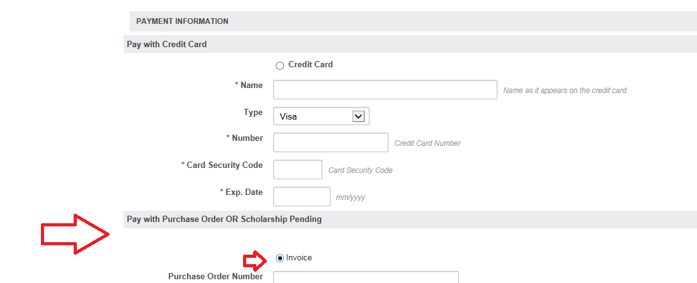
Depending on course length, local participants may receive preference over those who need to travel long distances for tuition-only scholarships.
RCAC will notify scholarship applicants if they have received a scholarship. Scholarship recipients will have five business days to accept/reject their award. If RCAC doesn’t hear back from the Scholarship Recipient within that time frame, the scholarship may be awarded to another participant.
Recipients have 5 business days after notification to accept or reject the scholarship. No response is automatic rejection and scholarship will not be available for substitution within the agency.
Scholarship Recipients will book and pay for their own travel and be reimbursed up to the scholarship limit. Recipient must submit a reimbursement request no later than 30 days after the training has ended. Cancellation of travel with the airline is the responsibility of the Recipient.
Lodging Scholarship Recipients must stay at the hotel selected by RCAC or the recipient will be responsible for lodging. RCAC will book lodging for scholarship recipients and pay for it minus any charges beyond lodging, tax and fees that are incurred by the recipient. Please note that the hotel will ask for a personal credit card upon check-in for incidentals and they will place a hold on that card.
If after accepting the scholarship you cannot attend the training, please let us know as soon as possible so that we can cancel your hotel reservation. If you neglect to notify us that you cannot attend the training at least 36 hours in advance, we will not offer you nor anyone from your agency a scholarship for a period of one year.
If Scholarship recipient cannot make the class, they may substitute an employee within their agency with no penalty. Recipient(s) will be responsible for altering travel and lodging arrangements. If a Scholarship Recipient does not attend the full class with attendance noted by the instructor, their scholarship is null and void. If a Scholarship Recipient does not show up to class, they are responsible for any charges they have incurred and they will be ineligible for a future scholarship from RCAC for a period of at least one full year.

