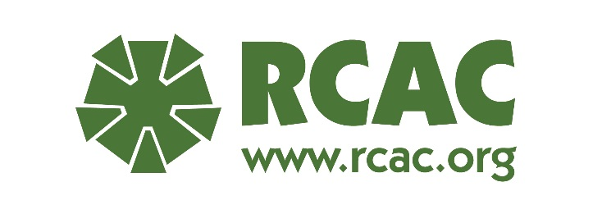
Who can Attend RCAC Classes and Webinars?
Classes are available to those employed by a HUD-approved counseling agency. At registration, participants will be required to identify their HUD number. If a counseling agency is still in the HUD approval process, RCAC will need to secure approval from HUD for the participant to be allowed scholarships for the class.
For profit agencies will NOT be eligible for any scholarships but can attend classes.
All Students MUST register for classes using the registration link provided. No email or fax registrations will be accepted.
For multiple day webinars, students must attend all sessions in order to be able to pass the test to obtain a certificate of completion.
Class Fees Policy
Registration fees are $50 per day for in-person classes. For example, a four day class would have a tuition fee of $200. A non-refundable tuition fee will be collected at time of registration. This is non-refundable unless the participant cancels up to 14 days before the class begins, the refund will be returned for half the amount paid. Live classes start at 8:30am and end at 4:30pm. Any attendance issues need to be discussed with the instructor
Webinars are $50 no matter if it is one day or multiple days. Registration fee must be paid at the time the participant signs up or it will be null and void. There will be no refunds for webinar registration. Webinars are from 10:00-12:00 PST.
If the link to a webinar is given to others who did not properly register for the class or pay the fee, they cannot receive the materials for that class or receive a certificate.
All participants must register for classes using the registration link provided. No email or fax registrations will be accepted.
Scholarship Policy
Scholarships will be offered on a first-come, first served basis by registration date with an allowance for balancing attendance from throughout the country. Scholarships are usually awarded within two weeks of registration opening for a class. Acknowledgement of a registration does not mean that a scholarship has been awarded.
RCAC will consider multiple scholarship applications from the same agency with the additional requests dropping to the bottom of the scholarship request list. If no new agencies/counselors apply for scholarships and an agency has previously received a scholarship for one of its counselors, RCAC will give priority to awarding a scholarship to a new recipient in that agency before providing a second scholarship to the same counselor.
If a participant’s travel exceeds 50 miles that participant would be eligible for a travel and lodging scholarship. Travel is for airfare only unless permission granted for mileage reimbursement. Airfare is based on average cost at the time the scholarship is granted. Cost differences due to late purchase will be the responsibility of the recipient. The maximum amount allowed for travel reimbursement will be included with the scholarship notification email. Recipient will be responsible for all other travel expenses. RCAC follows GCA requirements. RCAC will not cover travel/cancellation insurance, seat upgrades, priority boarding, luggage fees, shuttle expenses, rental car bus or train.
Depending on course length, local participants may receive preference over those who need to travel long distances for tuition-only scholarships.
RCAC will notify scholarship applicants if they have received a scholarship. Scholarship recipients will have five business days to accept/reject their award. If RCAC doesn’t hear back from the Scholarship Recipient within that time frame, the scholarship may be awarded to another participant. No response is automatic rejection and scholarship will not be available for substitution within the agency.
Scholarship Recipients will book and pay for their own travel and be reimbursed up to the scholarship limit. Recipient must submit a reimbursement request no later than 30 days after the training has ended. A reimburse form will be provided a week prior to the class. Cancellation of travel with the airline is the responsibility of the Recipient.
Lodging Scholarship Recipients must stay at the hotel selected by RCAC or the recipient will be responsible for the cost. RCAC will book lodging for scholarship recipients and pay for it minus any charges beyond lodging, tax and fees that are incurred by the recipient. Please note that the hotel will ask for a personal credit card upon check-in for incidentals and they will place a hold on that card. All rooms are individual not shared.
If after accepting the scholarship the participant cannot attend the training, please let us know as soon as possible so that we can cancel the hotel reservation. If the participant neglects to notify us that they cannot attend the training at least 14 days in advance, we will not offer a scholarship to the agency for a period of one year.
If Scholarship recipient cannot make the class, they may substitute an employee within their agency with no penalty as long as they have given RCAC 14-days notice. Recipient(s) will be responsible for altering travel arrangements and RCAC will make the change with the hotel.
If a Scholarship Recipient does not attend the full class with attendance noted by the instructor, their scholarship is null and void. If a Scholarship Recipient does not show up to class, they are responsible for any charges they have incurred and they will be ineligible for a future scholarship from RCAC for a period of at least one full year.

