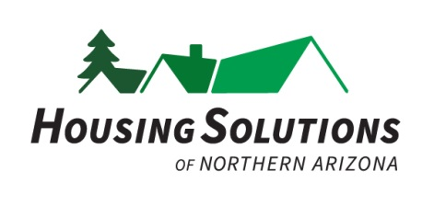

Housing Solutions of N. Arizona
Job Description

Position Title: Sharon’s Attic Sales Associate

Employment Details: Part-time – Approx 25 hrs/wk
Store coverage include hours Wed-Sun 8:30 a.m. to 5:30 p.m.
Days and hours subject to change based on coverage need
Non-Exempt Position
Starting Wages: $16.80
Benefit eligible

Job Location: 1926 N. Fourth St., Ste. 5
Flagstaff, AZ 86004

Housing Solutions of N. Arizona History:
Housing Solutions of N. Arizona, Inc. is a local 501(c)3 nonprofit organization whose mission is to build opportunity for sustainable, affordable housing in northern Arizona. Founded in 1990 as the Affordable Housing Coalition, the organization’s main programs include housing counseling, construction of affordable housing and Sharon Manor, a transitional housing facility for homeless women and children survivors of domestic violence. In May 2014, the organization changed its name from BOTHANDS, Inc. to Housing Solutions of N. Arizona (HSNA).

Summary:
In March 2014, HSNA opened Sharon’s Attic, a thrift store, which specializes in sales of items for children (toys/clothing), babies, household goods, furniture, and clothing. The primary duties for this person are for pick-up and delivery of donated items, including furniture. This person will also provide customer service to shoppers in the store and donors. He/She will help customers with check out and purchase of their items and will assist with incoming donations. This person will answer telephone inquiries and work to schedule donation pickups. He/She will assist in maintaining the store in a clean and safe condition. This person will work in a team environment with other staff members and volunteers. Reports directly to Sharon’s Attic Store Manager.

Essential Duties and Responsibilities:
- Assist and perform all store operations:
  - Assisting customers in the store with questions and purchases
  - Assisting donors with their donation
  - Thanking donors for their contributions and providing donation receipts
  - Working with volunteers
  - Operate check-out register; provide customers with correct change and process credit cards for purchase
  - Assist in completing end-of-day sales/reconciliation reports
  - Answer questions regarding store, operations, donations, etc. in person and on the phone
  - Schedule donation pick-ups
  - Clean the store and ensure it is clean and safe
  - Inventory, sort, price and display merchandise for sale
  - Serve as an advocate for Housing Solutions of N. Arizona, helping to answer basic questions about the organization and its programs

Minimum Qualifications:
Able to lift 30 lbs on a consistent basis
Clean driving record
Great customer service skills
Ability to work with a diverse group of staff and volunteers
Ability to work unsupervised and be a self-starter
Good decision-making skills
Good cash handling skills and able to operate point of sale terminal (or ability to learn)
Able to multi-task in a fast-paced environment

Preferred Qualifications:
Bilingual in Spanish

